Oceans of Possibilities summer reading program
Kickoff program 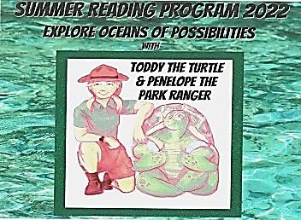
These programs were made possible by funding from Library of Michigan LSTA grant
Wk. 1: Tues. June 14th 10:00-11:30am at the Morley Community Center PreK-6 Special story presenters and crafts
Wk 2: “What would you in the ?” Tues. June 21st. 10:00-11:30am at the library PreK - 3rd
Wk 3: “ 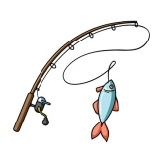 for a Story” Tues. June 28th 10-11:30 at the library PreK-3rd (A SPECIAL READER PLANNED FOR THIS DAY READING A VERY SPECIAL BOOK)
Wk 4 :“Wishing Upon a ” Tues. July 12th Library 10-11:30at the library Pre K-3rd
Wk 5: “Looking forat the OK 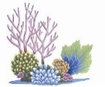 ” Tues. July 19th 10-11:30 at the Library PreK-3rd
Wk 6:“Eight ways to Hug an ?” Tues. July 26th 10-11:30 at the library PreK-3rd
^{BOOK CLUB FOR GRADES 3-6 :}
Sign up starts the week of June 14th, with completion date of July 26th.
Participants will read and record books in their reading level or above. Those who complete the required number of books by the end of the program will have their name entered in a prize drawing at the end. We are also working on some hands on activities/crafts for this age group with more information to follow.
FOR MORE INFORAMTION CONTACT WALTON ERICKSON PUBLIC LIBRARY 231-856-4298
^{Or Ctaylor@morleystanwood.org}

